|  |
| --- |
|  |
| **A Report**  **On the Implementation of the Administration of Criminal Justice Law 2011 of Lagos State** |
| Written By Access to Justice |
|  |
|  |
|  |

|  |
| --- |
|  |

INTRODUCTION

**Executive Summary**

In an effort to improve the delivery of civil and criminal justice, ensure better safeguards for the rights of criminal suspects as well as drive the effective implementation of laws by justice sector institutions, Lagos State has initiated and led a series of reforms targeted at improving the administration of civil and criminal justice in the State post 1999. These reforms rode on the back of specific new Laws which include the Administration of Criminal Justice Law 2007 (amended and re-legislated in 2011, and hereafter simply called “ACJ Law”), the Magistrates Courts Law (2009) (amended in 2011) as well as the Magistrates Court Rules. Among other things, the ACJ Law improved safeguards for the making of statements by crime suspects, created an oversight system for remand detention and expanded sentencing options to include non-custodial sentencing. These reforms were expected, inter alia, to ease prison congestion, and end the abuse of the remand system. Sadly, more than five years after the introduction of these reforms and in spite of their lofty goals, the outcomes envisaged by these specific legislations have not been achieved.

This is the report of the assessment undertaken by **Access to Justice** (hereafter AJ) that looked at one of the major facets of the reforms – the changes introduced by the Administration of Criminal Justice Law, 2011, of Lagos State. The report contains findings and facts from a detailed study embarked upon by a team of legally-trained researchers which focused on ascertaining the level of awareness of, compliance with, implementation and enforcement of the new Law by the law enforcement officials as well as civil society in Lagos State.

The overriding objective of the research is to bridge the gaps militating against the understanding, implementation, enforcement and successful operation of the reforms introduced by the Lagos State government to address long-standing problems in the administration of criminal and civil justice in the State. This Report identifies specific impediments to the implementation of the new Law and obstacles to the achievement of criminal justice reform objectives and offers recommendations that can plug these gaps.

This report is a prequel to the implementation of a set of interventions designed to strengthen the implementation of the ACJ Law and, by doing so, support the achievement of the aims and objectives of the reform legislations. This project aims to build awareness and understanding of the reforms among law enforcement communities and sectors, and provide training on the reforms in order to give effect to, and entrench them. This research and the substantive project has been made possible by the support of the Justice for All (J4A) programme of the British government’s Department for International Development (DFID) to whom AJ expresses its deep gratitude.

**Background**

Across Nigeria, many daunting problems are found within the administration of justice, at both State and Federal levels, and these problems exhibit commonalties across board: the hauling of crime suspects into court before investigations can make headway, the excessive time taken to conclude crime investigations and consequential remand of suspects pending conclusion of investigation or trial; weak records-keeping systems from which cases being tried accidentally but occasionally slip out into oblivion, and poor judicial oversight over “remand” detention leading to prolonged pre-trial or under-trial imprisonment of criminal defendant[1]. Then there are issues of punishments, and how to use modern sentencing options to reduce prison congestion.

Protracted pre-trial or under-trial incarceration, often the by-product of flawed remand procedures across many States in Nigeria, violates the civil rights of detained crime suspects in a brutal way; yet, it is mostly the poor and vulnerable who are often caught in the perilous loops of broken or weak, criminal justice systems which produce these injustices across federal and states’ boundaries.

Indeed, across Nigeria, oversight of remand processes and detention is virtually entirely lacking: where they are present, they are superficial, patchy, marginal or too slack to offer any reasonable safeguard for persons who are taken through that course of movement. Lagos State took a bold step to address some of these weaknesses when it legislated changes to its criminal procedure laws, first in 2007, and then, in its re-enacted version in 2011.

The ACJ Law addresses these flaws by providing for (inter alia):

1. Enhanced rights of accused persons to obtain legal representation, furnish bail and have the attendance of legal counsel during interrogation (sections 9(2) and (3).
2. Expanded rights to seek judicial review of detention and release on bail,– section 18 (1)-(3)
3. Enlarged power of the Attorney General to withdraw, at the Magistrate Court through a Legal Advice, any charges made against accused persons in the course of remand proceedings – section 72
4. Expanded powers of the remanding Magistrate to control the remand process and exercise discretion to release crime suspects on bail in appropriate circumstances – section 264
5. Greater obligation on the part of the Police to supply justification for extended remand warrants – section 264
6. A structured time period within which a remand order shall last, and a structured level of obligation on remanding Magistrates to inquire into the state of police investigations and to release crime suspects unless good cause against the alleged offender is shown
7. Power given to Magistrate to make Orders requiring remanded defendant be brought before the court. – section 265.

Alongside this, the Law empowers Magistrates to refer civil causes to mediation and arbitration (section 36) as well as “encourage the settlement in amicable way of proceedings for common assault or for any other offences not amounting to felony and aggravated in degree, on terms of payment of compensation or other terms approved by him” (section 37). These reforms are expected to see Magistrates facilitating the use of non-formal institutions for dispute resolution in both (non-felonious) criminal and civil cases. This effort by Lagos State has inspired similar reforms among a number of other States who face similar problems

**Are the Reforms Working?**

About six years from the time the changes were first enacted into law, and two years after the more recent amendments to the Administration of Criminal Justice Law, we noticed that, within our spheres of interaction, the reforms did not appear, from anecdotal evidence, to be producing actual on-the-ground changes and the behaviour of law enforcement officials did not appear to have taken account of new legal realities in Lagos State. This means that things remained like they were prior to 2007 and this was a little troubling.

This study is an effort to understand why so little appears to have changed in spite of the creative push for reform in Lagos State. Our research validates the experience of many: not much has changed within police institutions and even in the courts since the introduction of this law.

**Why?**

Notable amongst the causes for this, is a pervasive ignorance of relevant provisions of these laws by institutions directly obligated by the laws – the police (or law enforcement agencies) and the magistrates. Part of the reason, or we could say, in fact, the main reason being the lack of awareness of the law and the changes it introduces. Whether this lack of awareness is indeed borne from some kind of knowledge apathy or indifference to novelty by these actors is something that could also be interrogated at another level. From our findings, only 29% of police officers in Lagos State are familiar with the ACJ Law 2011 (as amended) or have received any formal training on the provisions of the Law. Furthermore, whereas 84% of lawyers are acquainted with the provisions of the ACJ, Law, only 14% of them have attended any kind of training or stakeholders’ interaction on the ACJ, Law. In contrast, 96% of magistrates report that they have participated in trainings and sensitization workshops on the ACJ Law.

**Arrests**

Little change has occurred with regard to reforms relating to arrests by law enforcement groups. Magistrates unanimously report that the police do not usually inform them of cases of persons who are arrested and kept in police custody without being offered bail, or of persons who are arrested without a warrant and are detained without any charges brought to court. Corroborating this, 92% of police officers interviewed indicated that they do not notify district magistrates of cases of persons arrested. Indeed, 70% of the police officers interviewed reported that they are not aware of this requirement of the law. Still 40% of the police officers added that there are no existing templates or forms provided in the Law which can serve as a guide for such notifications to guide them in fulfilling this requirement.

**Information of Cause of Arrests and Availability of Legal Assistance**

65% of police officers reported that they usually inform suspects of the cause of arrest only at the point of detention after the suspect arrives at the police station. They cited the prevention of suspects’ resistance of arrest as the primary reason for this practice. In another vein, 96% of sampled inmates and 92% of the sampled lawyers reported that police officers do not inform arrested persons of their rights to apply for bail or free legal representation nor do police officers provide any facilities for arrested persons to apply for free legal counsel or representation from the office of the public defender, legal aid or other NGOs. 75% of the police officers confirmed this position.

**Bail Measure and Sureties**

AJ’s research findings indicate that there have been no real improvements in the practice of bail in Lagos State since the time of the commencement of the ACJ Law till date. 75% of the lawyers and 89% of the prison inmates interviewed stated that the police do not release detained suspects on bail where it is impractical to bring such suspects to court within 24 hours, thus continually flouting a major constitutional safeguard. All interviewed Magistrates further reported that the police do not notify the courts or tender reports which disclose persons under police custody who have not been admitted to bail or and were arrested without any warrant, required under the ACJ Law which position was affirmed by 78% of the police officers interviewed. Still in connection with bail, 9% of police officers interviewed still maintain the practice of not accepting women as sureties when granting police bail except, according to them, when dealing with “educated and working class women”. This is, according to these officers, due to the emotions women bring into the handling of criminal cases. In another vein, 74% of the lawyers have revealed that the police do not assist arrested persons in processing bail or making arrangements for a defence except they benefit financially from rendering that assistance. 88% of sampled inmates indicated that the police officers in charge often took advantage of their relatives’ desperation to secure their release and demanded huge sums of money from them in connection. From the above findings, it is evident that the process of granting and obtaining bail in Lagos State remains fraught with numerous irregularities despite the reforms and the good intentions backing them.

**Reform of the Remand Procedure**

Sadly, much unjustified time continues to be wasted between the filing of information or charges against suspects and the eventual trial of such suspects who are typically left to languish under grueling detention or prison conditions. 86% of police officers report that they do not apply to magistrates for the extension of previously issued remand orders against persons arraigned and remanded by the courts. 55% of lawyers report that many of the magistrates in Lagos State do not comply with the oversight safeguards enshrined in the ACJ Law concerning adjournments with respect to persons detained under remand orders. On their part, magistrates unanimously agree that police officers do not notify them whenever an incident of arrest takes place and where bail is not granted to the arrested suspect. The failure to exercise adequate oversight over remand detentions has also negatively impacted prison demographics. As at the time of this research, the Medium Prison, Kirikiri with a capacity of 1, 700 inmates, held 2,592 inmates out of which 2, 437 were awaiting trial inmates otherwise termed as remand prisoners. Similarly the Medium Prison, Badagry with a total capacity of 160 inmates, is home to 509 inmates out of which 204 were remand prisoners. Finally, the Medium Prison Ikoyi, with an 800 inmate capacity, houses 1847 inmates, out of which 1, 709 were remand prisoners.

**Confessional Statements**

Provisions relating to the taking of confessional statements of suspects have remained grossly ignored by the police and unenforced by magistrates. Besides safeguarding the constitutional rights of suspects, these provisions could also have eased concerns over the voluntariness of confessional statements and reduced the frequency of attacks on those statements. Virtually all those interviewed – police officers, prison inmates and Lawyers were all nearly unanimous in saying that police officers do not make video recordings when obtaining statements from arrested persons, neither do they alternatively make sure that a lawyer is present first before embarking on an interrogation or obtaining a statement from an arrested person. A major barrier to the entrenchment of this particular reform has been traced to the overriding provision of the Evidence Act which does not make video evidence mandatory for purposes of admitting confessional statements. Such objections continue, notoriously, to serve as a fundamental cause of delay of criminal trials arising from time spent in conducting trials within trials.

**Community Sentencing Orders**

The perennial problem of prison congestion is no doubt worsened by the discernible failure of magistrates to embrace forms of non-custodial sentencing as an alternative to imprisonment provided under the Law. Community service, in place of prison incarceration was, among other purposes, aimed at prisons decongestion by avoiding prison sentences for first time offenders or minor offences. Surveys show that community service is now being used as a sentencing option, with 82% of Magistrates reporting that they currently employ community sentence orders for the most minor offences – such as the theft of mobile phones - particularly where stolen items have been recovered, or traffic or environmental offences. However, these magistrates say they have no confidence in its effectiveness. According to the magistrates community sentencing orders have become an ineffective form of sentencing due to failure in supervision and enforcement and so does not deter crime. In fact, 18% of magistrates reported that due to the challenges of enforcement, they do not make community service orders at all but would rather impose fines on persons convicted of minor offences or first time offenders.

**Speedier Trial Procedures in the High Courts and Alternative Dispute Resolution (ADR)**

Not much appears to have changed in the time taken to complete case-file assignment formalities within Lagos State since the operation of the ACJ Law. 74% of the lawyers interviewed stated that the assignment of newly filed cases before a judge does not take place until well over thirty days from the date of the filing of the information or charge. This is in contrast to Section 256(2) of the ACJ Law which requires the Chief Judge of Lagos State to assign all newly filed cases to a judge within 15 days.

For ADR, the evidence is that not much progress again, has been achieved here: Magistrates readily admit a reservation for the use of the process on the grounds that litigants themselves lack confidence in ADR and are wary of the outcome of justice using ADR. 56% of the magistrates stated that they will only refer parties to ADR where the parties both give consent and can assure the court that justice will be adequately served by the chosen ADR process. However, whilst attributing their stance to perceived public attitudes and distrust for the ADR process, most magistrates themselves have misgivings towards the use of ADR within this context. These misgivings must be addressed in the interest of enhancing public recourse to the ADR system.

Conclusion

Have the reforms introduced by Lagos State changed the landscape of criminal justice administration? The answer at this time is no: they have not. Not because they lack the power to, not because they come short in any known respects but because they have mostly been ignored or are yet to be taken seriously by those whom they bind. The basic inference, from this research, is law enforcement institutions in Lagos State have fallen short in implementing the reforms introduced by the ACJ law. This will need to change for the reforms to stand a chance of achieving its goals or producing some impact in the State. Former Lagos State Attorney General and Commissioner for Justice, Mr. Olasupo Shasore (SAN) sums this up well when he said, *“The success of any system of criminal justice administration depends on the level of efficient performance of responsibility imposed by law on agencies involved in criminal justice delivery. Some of the problems confronting the administration of criminal justice in Lagos State are traceable to the failure by criminal justice agencies to perform the legal responsibilities.”[2]*

**Research Methodology**

The research was conducted by a team of five field researchers, a research assistant and a lead coordinator. Over a three month period AJ’s team of researchers conducted visits covering courts (Magistrates courts), and police stations within Lagos State in order to gather and collate information showing the extent to which officials of these law enforcement institutions were enforcing the reforms introduced by the ACJ Law.

These researchers administered questionnaires to Magistrates across the magisterial districts in Lagos State and randomly selected Police Officers in selected Police Commands scattered across the State. The Magisterial districts and courts visited include:

1. Yaba Magistrate District
2. Badagry Magistrate District
3. Ikeja Magistrate District
4. Apapa Magistrate District (Agbo-Malu, Wharf, Kirikiri)
5. Surulere SUB Magistrate District (Pilot Crescent and Bassey Ogamba)
6. Epe Magistrate District (Ibeju Lekki, Magbalade)
7. Igbosere Magistrate District
8. Ikorodu Magistrate District
9. Isolo Magistrate District (Mushin, Ejigbo)

Police locations visited include: Apapa Police Area Command; Zone 2 Command Head quarters, Onikan Division, Ikoyi; Area A (Lion House), Lagos Island Division; Pen Cinema Police Division, Agege; Economic and Financial Crimes Commission (EFCC), Ikoyi; Badagry Police Station; Marine Police Division, Badagry; Ikeja Police Head quarters; Adekunle Police Station, Yaba; State Criminal Investigation Department, Panti; Sabo Divisional Police Station; Ajeromi Police Station; Alausa Police Station; Makinde Police Station; Ojodu Police Station; Akinpelu Police Station; Shogunle Police Station; Mosafejo Police Station; Mushin Police Station, Ladipo Police Station, and Surulere Police Station.

The Researchers also administered questionnaires and conducted interviews/interactions with lawyers and crime suspects, remand prisoners and prison in-mates. Some of the Prisons visited include:

1. Federal Prison Badagry
2. Kirikiri Female Prison
3. Kirikiri Medium Prison
4. Ikoyi Medium Prison

A total of 228 lawyers, 209 police officers, 33 magistrates, 4 prison wardens, 120 inmates and 2 community service officers were interviewed through administered and filled questionnaires as well as in-person interviews. In addition the Researchers observed proceedings in court and in police stations. They also interviewed police prosecutors and court staff. This field research helped them identify the main obstacles and gaps impeding the full implementation of the reforms in both courts and law enforcement centers, which now form the subject of this Report.

*MAIN REPORT*

**Reforms Introduced under the Administration of Criminal Justice Law of Lagos State, 2011**

One of the distinctive features of the reforms introduced by the Administration of Criminal Justice Law (ACJ Law) of Lagos State is that it created a number of safeguards, procedural and substantive that are intended to minimize the risks of violations of due process rights, used loosely to mean, in this context, the rights of persons who are walked through the criminal justice “process”: These safeguards begin from the time of arrests, and run through the trial spectrum up to the time of sentencing.

**Challenges of Implementation of the Law**

1. **Level of Stakeholder Awareness of ACJ Law**

The first point of concern is the marked contrast in the level of awareness and familiarity which Magistrates and law enforcement officials possess of the ACJ Law as well as the new safeguards it has furnished to protect against oppression and abuse. Among Magistrates, knowledge of the law and the changes it establishes is high. 96% of Magistrates surveyed indicated that they not only know of this law and the contents of its provisions, but they have also attended formal trainings and seminars on the Law. This is in marked contrast with the situation of police officers; only 29% of the police officers report that they are familiar with the ACJ Law and have received formal training on its provisions. 84% of the lawyers indicate that they have studied and are familiar with the provisions and workings of the ACJ Law. However, only 14% of the lawyers indicate that they have attended formal training on the ACJ, Law.





1. **Arrests** :

The powers of arrest in Nigeria are vested primarily in the police and specialized law enforcement agencies such as the Economic and Financial Crimes Commission (EFCC), the Independent Corrupt Practices Commission (ICPC), the Nigerian Drug Law Enforcement Agency (NDLEA), Nigerian Security and Civil Defence Corp (NSCDC), Nigerian Customs Service (NCS), and the State Secret Service (SSS). Section 4 of the Police Act[3] authorizes the police to apprehend offenders for the preservation of law and order, the protection of life and property and the due enforcement of all laws and regulations with which they are directly charged.

The police are also empowered under the Criminal Procedure Act and the Criminal Procedure Code in Nigeria to conduct arrests, with or without warrants – provided certain conditions are met in the case of arrests without warrant in connection with their duties of crime prevention, detection and investigation as well as in the course of regulating public order and safety including traffic regulation[4]. Other law enforcement agents such as the NDLEA, EFCC, ICPC, and NSCDC, amongst others are empowered to conduct arrests under relevant legislation which establish them and spell out their functions. Judicial officers, who include judges and magistrates, are also empowered under the law to carry out arrests under certain conditions[5]. Private citizens may also conduct arrests where they witness a suspect committing a crime, provided that any person arrested by a private citizen shall be immediately handed over to the police.

Every arrest must conform to the conditions stipulated by law and be consistent with the Constitution of the Federal Republic of Nigeria, 1999. A person arrested has the right to be informed of the facts and grounds of his arrest. At the police station or detention facility, a suspect is entitled to be informed of his/her rights in relation to making a statement and may refrain if he/she so wishes from making a statement until after consultation with an attorney. Section 35 (2) and (3) of the 1999 Constitution provides for the right of arrested persons to avoid answering any questions by the arresting authority until after consultation with a legal practitioner.

However, due in part to the non-observance of these constitutional safeguards over the years and the culture of arbitrary behaviour prevalent in making arrests and detentions, the Lagos State government embedded new provisions in its ACJ Law, that imposed additional responsibilities on the police when exercising their powers of arrest and detention of suspects. These responsibilities include:

1. A Police officer is obliged to notify a person arrested of the reason for the arrest and his rights upon arrest, including the duty to inform the arrested suspect of his/her right to free legal representation through the Office of the Public Defender established by the Lagos State Government - Section 3.
2. A Police officer cannot arrest a person who has not committed an offence in lieu of a suspect - Section 4.
3. It is now mandatory for a Police officer effecting an arrest to make an inventory of items recovered or taken from the body, premises, or about the person arrested and to ensure that the person retains a copy of the inventory -Section 6.

Actual Practice

Information gathered from this research shows that there has been no significant improvement in the practice concerning arrests and detentions in Lagos State since the introduction of the ACJ Law.

**Notification of Cause of Arrest: Section 3 (1) of the ACJ Law**

The ACJ Law stipulates that except where apprehended in the actual course of the commission of a crime or where pursued immediately after the commission of a crime or arising from an escape from lawful custody, arrested persons are to be notified of the cause of arrest at the point of arrest. 81% of the lawyers sampled in our survey said the police do not give arrested persons information of the cause of arrest before or at the point of arrest. 14% indicated that the police sometimes notify suspects of cause at the point of arrest.

However, 65% of police respondents stated that the police usually inform suspects of the cause of arrest only at the point of detention after the suspect arrives at the police station. These police officers cited the fear of suspects resisting arrest as the primary reason behind their non-compliance with this requirement. 35% of the sampled police officers however said that they usually inform the suspect at the point of arrest of the reason for arrest.

**Information of the Right to remain Silent: Section 3 (2) (a-b)**

Under the ACJ Law, an arrested person may exercise the option to remain silent or avoid answering any question until after consultation with a legal practitioner or any other person of his own choice. 92% of the lawyers interviewed stated that the police do not inform arrested persons of their right to remain silent or avoid answering questions until after consultation with a legal practitioner. 63% of the police officers sampled admitted that they do not usually inform suspects of such right. 20% attributed this to the reason that providing such information to arrested persons will only serve to impede police investigations. 40% of police officers interviewed claimed that the presence of lawyers during questioning usually serves as a barrier as lawyers attempt to take over the questioning of the suspects themselves. 38% of the police officers however indicated that they inform arrested persons of their right to remain silent or consult with a lawyer before answering questions in the course of investigations.

**Notification of Right of the Defendant to Free Legal Counsel: Section 3(3) of the ACJ Law**

The ACJ Law provides that a Police Officer or person making an arrest shall inform the person arrested of the legal right to apply for free legal representation from the Office of

the Public Defender, Legal Aid Council or any such agency. Unfortunately, 75% of the sampled police officers admitted that they do not inform arrested persons of their rights to seek legal counsel of their choice or alternatively to apply for free legal counsel or representation from the office of the public defender, legal aid council or other NGO for legal assistance. 96% of the prison inmates sampled indicated this same position. 92% of the lawyers also reported this same position.

**“Hostage” Arrests: Section 4 of the ACJ Law**

The ACJ Law provides that no person should be arrested in lieu of a suspect. 10% of police officers admitted that, where a suspect sought to be arrested is not found and is perceived to be in hiding, they are likely to arrest a close relative or member of the family of such a suspect in order to make the suspect show up. 12% of inmates reported that police officers still arrest non-suspects in lieu of the arrest of an actual suspect.

**Report of Arrests to Magistrates: Section 20 of the ACJ Law**

The ACJ Law expressly provides that Officers in charge of Police Stations are under an obligation to report the cases of all persons arrested without warrant within the limits of their respective police stations to the nearest Magistrate, whether such persons are admitted to bail or not.

Actual Practice

All the Magistrates interviewed for this research affirm that the police do not usually inform them of cases of persons who are arrested and kept in police custody without bail, or of persons who are arrested without a warrant and are detained without any charges brought to court. 92% of the police officers interviewed indicated that they do not, in practice, notify magistrates whenever an arrest of a suspect takes place. Different reasons were advanced for the non-observance of the newly instated procedures. First, 62% of police officers surveyed reported that they are not aware of this requirement of the law. 20% of them added that there are no existing templates or forms provided in the Law that serves as a guide for such processes or notifications and, in effect, they do not know how to go about with complying with this requirement.

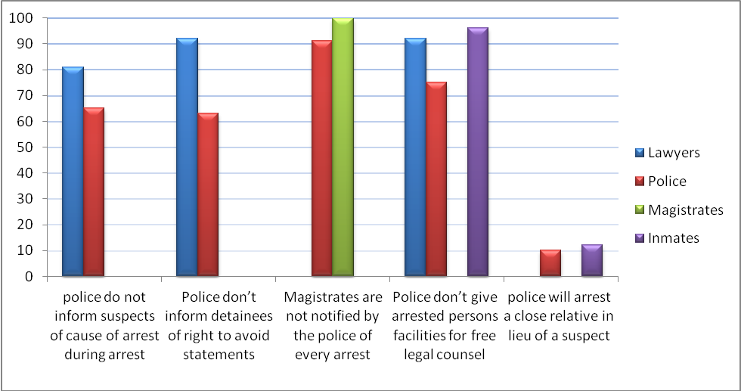

1. **Bail Measures and Sureties –**

In Nigeria, bail is a constitutional guarantee that is founded on Sections 35 and 36 (5) of the Constitution of the Federal Republic of Nigeria, 1999. Section 36 (5) provides for a presumption of innocence of an accused person until proven guilty. On the other hand, Section 35(4) expressly requires that any person arrested shall be brought before a court of law within a reasonable time, otherwise the person should be released on bail. The section goes further to define ‘Reasonable time’ in Section 35(5) as meaning a period of one day or two depending on the proximity of the detention location to a court of competent jurisdiction.

It is on the above premises that the police and courts are obligated to grant, with exceptions made in the case of capital offences, the provisional release of persons arrested until the completion of a related investigation or trial or until conviction. Bail may be offered at three stages within the criminal justice process. First, the Police may release a suspect on bail pending further investigation. Second, a court of law before which a suspect has been charged, may release the accused on bail pending the determination of the case against him or her, and, finally the courts in the exercise of discretion, may release a convicted person on bail pending the determination of an appeal against conviction.

The forms of bail and the terms and conditions upon which the courts and police may grant bail in Lagos State and across Nigeria, include bail on self-recognizance, bail on a bond for a fixed amount, bail on bond with sureties as well as deposit of money instead of a bond. Notably, bail in Nigeria is rarely granted on self recognizance alone. Bail is more routinely granted on bond with sureties, across Nigeria, and in Lagos State.

In practice, however, the bail process has been fraught with many illicit practices by the many parties involved in granting or processing it, ranging from the police, corrupt police prosecutors, corrupt court registrars, corrupt magistrates to touts. Prior to the ACJ Law, there were also people or “touts” in the various magistrates courts who had created a thriving professional business out of standing as sureties for accused persons released on bail. Another prevalent issue was the commonplace refusal of women as sureties for suspects granted bail by the police, clearly a discriminatory practice that offended the constitutional right of equality of persons and freedom from all forms of discrimination on grounds of gender.

The ACJ Law made a number of provisions designed to tackle some of these issues and check the widespread abuse of the right of access to bail. . The Law, in section 116 (3) & (4), empowered the Courts to require the deposit of money as security for bail by accused persons. Under this requirement such deposits are to be kept in an interest yielding account on behalf of Lagos State by the Registrar of the court and the deposits would only be returned to the accused person and or the surety upon the completion of the trial. This new requirement would gradually render unnecessary, the use of professional sureties and touts who roam the courts and make a living from standing as sureties to accused persons, readily presenting (usually false) documents of land title and ownership in doing so, and subsequently disappearing, together with the defendant.

Section 138 of the ACJ Law introduced a new requirement for the registration of bondspersons, required to be professionals or companies who will undertake to produce the accused person when required by the courts. The provision also vests powers in the Chief Judge to make regulations, governing the use of bondspersons. In another vein the invidious practice of discriminating against women by not allowing them stand as sureties for bail was addressed in Section 118(3) of the ACJ Law which expressly prohibits such discrimination.

**Release on Bail of a Suspect Arrested Without Warrant: Section 17 of the ACJ Law**

The ACJ Law guarantees the rights of persons who are arrested without warrants by the police and for non capital offences, to be released on bail where it is impracticable to bring them before a court of law within twenty four hours. This is however subject to the fulfillment of bail conditions which are equally recognized under the same Law.

Actual Practice

AJ’s research findings however indicate that there have been no real improvements in the practice of bail in Lagos State since the commencement of the ACJ Law till date. 75% of the lawyers sampled stated that the police do not release detained suspects on bail where it is impractical to bring such suspects to court within 24 hours. On the other hand 89% of prison inmates sampled stated that they were not granted bail within twenty four hours in accordance with the ACJ provision, and, furthermore, that despite being kept in detention after arrest, their cases were not taken to court until well after the period prescribed by the Constitution. 8% of the inmates reported that though granted the option of bail by the police after arrest, they were unable to exercise the option due to the stringency of bail conditions offered.

**Report of Suspects not granted Bail by Police: Section 20 ACJ Law**

78% of the police officers interviewed indicated that they do not notify magistrates whenever a detained person is refused bail by the police unless a charge or information is brought against such a suspect before the court. This fact is reiterated by the magistrates: a total (100%) of the Magistrates interviewed stated that the police do not usually notify them whenever they conduct an arrest and even still where the suspect is not granted bail by the police. These magistrates further stated that the police do not tender any reports to the courts which disclose a list of persons under police custody who have not been admitted to bail or who were arrested without any warrant, as required by the ACJ Law.

**Women as Sureties for Bail: Section 118 (3) ACJ Law**

Section 118(3) of the ACJ Law expressly prohibits the denial, prevention or restriction of any person from entering into any recognizance or standing as surety or providing any security on the ground that the person is a woman. However in practice this is currently not fully complied with. 11% of the lawyers sampled stated that the police sometimes prevent women from standing as sureties for persons arrested and detained within police detention facilities.[6]On the other hand 9% of the police officers interviewed indicated that they will not accept a woman as a surety for a suspect to be granted police bail. According to the officers, their refusal to allow women stand as sureties is due to the sorts of emotions women raise at such occasions. However, these respondents say they will make exceptions for “educated and working class women”.

**Provision of Assistance to Suspects in Making Arrangements for Defence: Section 3 (3) and 9 (2) ACJ Law**

Under the ACJ Law police officers (or a persons making an arrest) are required to inform a person arrested of the right to apply for free legal representation from the Office of the Public Defender, Legal Aid Council or any such agency. Section 9 (2) additionally obligates the police to provide reasonable facilities that enable crime suspects to obtain legal advice, take steps to furnish bail and otherwise make arrangements for their defence or release.

In practice however, the police draw blank on this. 74% of the lawyers sampled stated that the police do not assist arrested persons in making arrangements for their defence or towards processing bail by obtaining free legal counsel or representation through legal aid agencies. None of the prison inmates indicated that they received assistance to get bail or legal assistance freely, while in police custody before a court issued remand order. 55% of the lawyers further added that where police officers render any form of bail assistance to arrested suspects through access to free legal representation, it usually comes at a price as reward is given for such help. From the above findings, it is evident that, when it comes to making facilities available to crime suspects for the preparation of their defence, or to access bail, not much has altered on the ground and the realities bear little co-relation with the legal responsibilities.

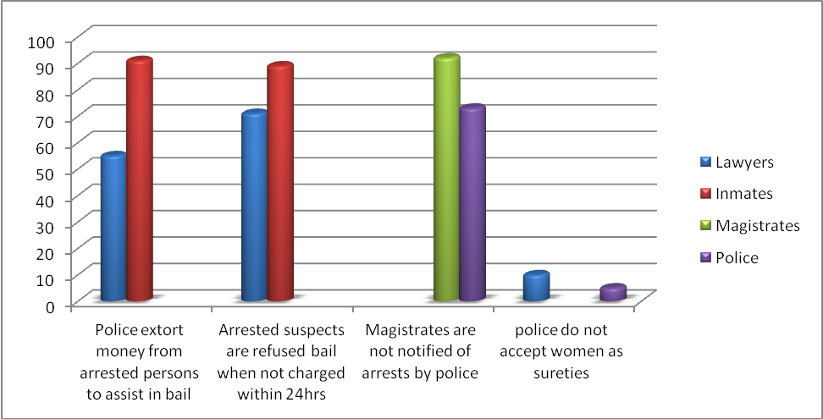

1. **Plea Bargain –**

Plea bargains have been notably used and associated with cases involving economic and financial crimes. However, no previous legislation – both Federal and State, - made provisions for plea bargain until the passage of the Economic and Financial Crimes Act, 2003[7]. Although plea bargain is not expressly mentioned in the EFCC Act, the idea is however arguably supported in the Act by implication[8], and this has since become the foundation for plea bargain in the country.

Many groups in Nigeria, including lawyers, have criticized the application of plea bargain in the Nation’s legal system. Some notable cases which have so far been resolved through plea bargain include the money laundering cases against former Inspector General of Police (IGP), Alhaji Tafa Balogun as well as against former Chief Executive Officer of Oceanic Bank, Mrs. Cecelia Ibru, which required Mrs. Ibru to forfeit 199 assets and funds worth about N190 billion. The cases against former Bayelsa State Governor Diepriye Alamieyeseigha, former Governor of Edo State, Lucky Igbinedion are other examples of the plea bargain outcomes[9].

The Lagos State Government broke new ground when it opted to formally legislate plea bargain procedures into law, making the state the first to do so expressly in Nigeria. In doing so, it made plea bargains available, as a means of resolving a vast range of criminal indictments – and not limited to economic and financial crimes alone.[10] The new law imposes duties on the court to ensure that plea bargaining is not abused and that the results do not compromise a reasonable standard of justice or tarnish judicial confidence. Therefore it vests powers in the court to supervise the process by advising prosecution as to sentencing options or the acceptability of a sentence agreed by the negotiating parties, without actually participating in the negotiation of a plea bargain.

However from our findings, plea bargaining has been sparingly used, and is not a window that many prosecutors or defendants have actively sought to use..

1. **Confessional Statements by Suspects**

Courts of law in Nigeria rely on the Evidence Act in defining confessional statements and evaluating what would be admissible as one. To qualify as a confessional statement, a statement of guilt made by an accused person must be direct, positive and unequivocal. The Supreme Court has held that once a confessional statement is direct, cogent and unequivocal to the admission that the accused committed an offence, the prosecution need not prove the offence any longer for the confession is enough proof of the offence beyond reasonable doubt[11]. Accordingly, confessional statements as a form of evidence are regarded by the courts as the ‘best evidence’ in order to secure a conviction.

In order to be admissible as evidence in court, a confessional statement must be made freely and voluntarily by the accused person. The Evidence Act renders inadmissible any confessional statement obtained by oppression of the maker or in consequence of any act or statement likely, in the circumstances existing at that time, to render such a confession unreliable. Once an objection as to the reliability of a confessional statement is raised in court, it becomes the duty of the prosecution to prove to the court beyond any reasonable doubt that such a confession was made by the accused person and was not obtained in a manner contrary to the Evidence Act. Where an accused person objects to a confession on the ground that it was not made voluntarily, the courts must conduct a trial within trial. This is a separate trial which lies within the substantive trial of the charge. Only after a trial within trial is resolved will the court proceed with or recommence the trial of the substantive charge.

Trials within trials can be lengthy and protracted sometimes, and are a source of delay and distraction.

In an effort to strengthen the integrity and transparency of the interrogation process within the context of which confessional statements are made, the ACJ Law introduced specific reform provisions targeted at safeguarding crime suspects from abuse, oppression and exploitation by their captors which could in turn give rise to objections from these suspects in a subsequent criminal trial. Section 9(3) of the ACJ Law now compels police officers and other law enforcement agents to make video recordings whilst obtaining statements from arrested persons or, otherwise, in the absence of a video recording facility, requires that any statement made should be recorded in writing in the presence of a legal practitioner chosen by the arrested person.

However findings from the research show that the use of torture and other oppressive interrogation tactics are still widely employed by the police to elicit confessional statements from accused persons, and compliance with legislated safeguards is largely absent. Objections to the voluntariness of confessional statements are still routine in courts and still cause chronic delays in criminal trials.

**Access to Legal Consultation for Suspects before Obtaining Confessional Statements: Section 3 (2) of the ACJ Law**

The ACJ Law provides that a suspect shall have the right to consult a counsel of his choice before making or writing any statement or answering any question put to him after arrest. In practice, the reality is more defiant. 53% of the police officers interviewed for this study stated that they do not allow arrested persons opportunity to consult with legal practitioners before making any statement or answering any questions put to them after an arrest. According to them, this is because lawyers usually interfere with the process of obtaining answers from the suspects. Lawyers corroborated this, and 82% of those surveyed maintained that police do not allow arrested persons access to lawyers before obtaining statements from them or allow lawyers accompany such suspects during interrogation. Many of the lawyers reported that they are forced to wait at the police reception rooms or even outside the station whilst the police obtain statements from their clients. On their part, 85% of prison inmates reported that statements were obtained from them by the police as soon as they arrived at the police detention facility and before they secured any legal assistance or representation.

Furthermore, 55% of the lawyers interviewed indicated that the police deny lawyers access to their clients’ statements after such statements have been obtained. This has occasionally resulted in heated arguments and exchanges between lawyers and police officers. One lawyer recounted that he was detained in a police cell for 5 hours after demanding that his client’s statement be shown to him by the police officer in charge of the investigation.

**Video Recordings of Confessional Statements: Section 9 (3)**

The ACJ Law requires that confessional statements by suspects must be recorded via video facilities. Section 9 (3) provides that the Police shall ensure that the making and taking of a confessional statement is recorded on video and copies of such recording are to be produced and tendered during the trial. Where, however, video facilities for such recordings are lacking, the confessional statements may be recorded in writing in the presence of a legal practitioner of the suspect’s choice. In practice however, this is not observed. 86% of the Lawyers sampled opined that police officers do not make video recordings when obtaining statements from arrested persons, neither do they alternatively ensure the presence of the suspects’ attorneys first before commencing an interrogation or obtaining a statement from an arrested person. 94% of prison inmates experienced the same breach. 86% of police officers interviewed admitted to this fact as well. However, 14% stated that they sometimes use their mobile phones to record statements made by suspects. The former explained that there are no facilities provided for such video recordings while obtaining statements from accused persons and so it is impractical to expect the police to observe such a requirement.

In addition, 27% of the police officers made reference to the conflicting position between provision of the ACJ Law regarding making video recordings and the Evidence Act which does not make video recording a pre-requisite for admitting confessional statements. 15% of the magistrates interviewed were of the view that there is a conflict between the ACJ Law and the Evidence Act regarding the use of video recording of confessional statements in trials. They stated that this will first have to be resolved before they can begin to enforce the relevant provision in the ACJ Law.

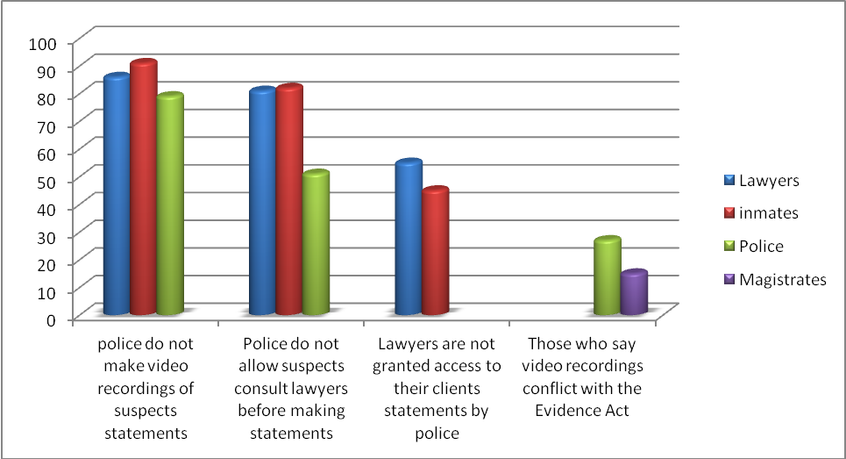

**Remand orders and proceedings –**

In Nigeria, if a suspect is arrested and consequently detained, he or she must be charged to court within twenty four hours or released on bail. Also, where, following an arrest, a suspect is placed under a remand order by a judicial officer, such a suspect should be made to undergo a trial for the offence within the prescribed time and not “forgotten” in prison while he or she awaits trial. It is unlawful for citizens to be kept in indefinite detention following an arrest. Section 35 (4) and (5) of the Nigerian Constitution provides the basis for remand detention. Similarly Section 236 of the Criminal Procedure Act[12] expressly empowers the courts to issue remand orders where bail is outside their discretion.

The abuse of remand detention prior to the ACJ Law had gained wide notoriety, with the result that prisoners on remand were detained virtually indefinitely without trial. Prison statistics in Lagos State alone showed that as at 2011, the medium security prison in Lagos, with capacity for 704 inmates, held 123 convicts and 1,917 awaiting trial persons. Similarly the medium security prison, Ikoyi, with 800 inmate capacity, held 124 convicts and 1,633 awaiting trial persons[13].

Faced with this history and legacy of remand imprisonment, the ACJ Law introduced certain improvements which make all instances of detention and custody of arrested persons subject to the supervision of magistrates. The law required magistrates to supervise the entire process of detention and prevent abuse of the remand system. Furthermore, this supervision would assist in decongesting prisons and police detention centres. Section 18, amongst other provisions, requires a police officer to immediately, upon an arrest, notify a Magistrate of a detention by means of an application. According to a disclosure by the then Attorney General of Lagos State, Mr. Olasupo Sasore SAN**[14]**, these provisions were intended to achieve the following objectives:

1. “Manage the process between arrest, investigation and formal charge and arraignment before a court of competent jurisdiction to try the offence;
2. Vest in Magistrate courts the supervisory jurisdiction and discretion to oversee the process of remand and to make appropriate orders and ensure that the relevant agencies perform their respective duties;
3. Empower the Magistrate by statutory provision to deal with remand proceedings, although the magistrate does not have jurisdiction to try the substantive offence; and
4. Ensure that the period of remand is within the constitutional stipulations of when a person can be detained without trial under Section 35(4) of the 1999 Constitution.”

Unfortunately, the remand situation in Lagos State remains painfully the same according to research findings and remand detention is still indiscriminate and largely unsupervised. In the opinion of most lawyers the performance of magistrates in protecting the rights of accused persons from unreasonable pre-trial detention is below average.

**Application for Extension of Remand Orders by Magistrates: Section 264 (6) (8)**

The ACJ Law sets the time limit for the duration of remand orders at thirty (30) days after which a detained suspect shall be subsequently released unless sufficient grounds for an extension of the remand order, which shall not exceed one month, are established. Section 268 (8) of the ACJ Law provides that a Magistrate shall extend the order to remand only if satisfied that there is a good cause shown and that necessary steps have been taken to arraign the person before an appropriate Court or Tribunal. Clearly the matter of extending a remand order is one subject to the discretion of the court and so the police or other detaining authority must make the requisite applications adducing sufficient and satisfactory grounds.

When sampled however, 84% of police officers serving as prosecutors stated that they do not apply to magistrates for an extension of previously issued remand orders against persons who are under court ordered remand detention. This is corroborated by Magistrates as 86% of them sampled report that police officers rarely, if at all, apply for the review or extension of remand orders which were previously issued by a magistrate. Again, 86% of magistrates stated that they do not in practice summon or issue hearings for the police to show cause why the remanded person should not be released, where a previously issued remand order has lapsed. Rather it is when the matter comes up for hearing that they make such enquiries in open court from the prosecutor. One magistrate further indicated that out of regard for personal safety, she prefers to avoid making orders against the prosecution for the procurement of remanded suspects in court during trial dates for fear of reprisal to herself by such a remanded suspect upon an eventual release.

**Court Hearings during Remand: Section 265 of the ACJ Law**

Section 265 of the ACJ Law stipulates that the court shall order a defendant to be brought before it during the period of a remand order. Most Magistrates do not observe these provisions. 55% of the lawyers sampled stated that many magistrates in Lagos State do not comply with the time restrictions regarding trial dates and adjournments with respect to persons detained under remand orders. They also say that many times court adjournments extend beyond thirty days especially in instances where the police prosecutors claim to still be investigating.

On their part, all 33 magistrates whose views were taken stated that they do not order for the production of a detained person in court or inquire into the circumstances constituting grounds for his or her detention unless a charge is first brought. According to them police officers do not notify magistrates of arrests which take place.

**Remand Orders to be Granted Based on Sufficient Grounds: Section264 (2) - (4) of the ACJ Law**

Section 264 (2)(3)& (4) of the ACJ Law provides, in effect, that an application for the grant of a remand order must contain the reasons for the remand, and those reasons which the court will consider include the nature of the offence, conduct, personality and social circumstances of the arrested person before making an order of remand. Notwithstanding this statutory guideline, 56% of magistrates surveyed stated that they are most likely to issue remand orders against arrested suspects irrespective of whether the prosecuting police officer failed to furnish sufficient reasons for such a remand order to be given or not, especially where the nature of the charge is severe. Further observations of court proceedings conducted within certain magisterial court divisions and districts[15], revealed that some magistrates grant remand orders upon mere oral applications made by the police, in respect of which no real evidence is furnished. According to 82% of inmates and 62% of lawyers, magistrates grant remand orders without considering the actual merit or strength of the applications before them.

**Report & Transfer of Records of Persons Arrested for State Offences without Warrants by the Police, to the Attorney General of Lagos State within One Week: Section 10 (3), Section 74 (1)**

Section 10 (3) of the ACJ Law requires police officers to remit the records of arrests of all persons who arrested without warrants under state offences to the office of the Attorney General of Lagos State within one week following the date of arrest. In addition Section 74 (1) provides that the Commissioner of Police of Lagos State shall cause to be transfered duplicate files or copies of records of persons arrested for indictable offences to the office of the Attorney General of the State for legal advice. In practice, however this is not being complied with. 85% of the police prosecutors stated that it is not in the practice of the police to remit records or transfer file copies of persons who are arrested in relation to state offences or indictable offences, to the office of the Attorney General. They added that where however the case is one involving murder or armed robbery then such reports are made to the Attoney General’s office for legal advice, and it is only over such instances that duplicate files are made or transfered.

Finally about 25 out of 33 magistrates interviewed for this study, in an instance of rare objectivity, stated that their performance in terms of protecting the rights of arrested persons against unreasonable detention has been average at best.

Current statistics drawn from prisons in Lagos State as at 2013, reveal no discernible shift or alteration of the injustices experienced under the remand system. According to official prison records disclosed as at the time of this research in 2013, the Medium Prison, Kirikiri, with a capacity of 1, 700 inmates held 2,592 inmates; of this figure, 155 were convicted persons whilst 2, 437 were awaiting trial inmates.

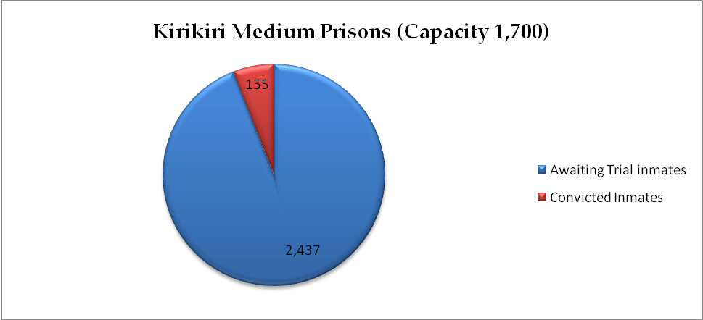

Current inmates = 2, 592

The Medium Prison Ikoyi (with an 800 inmate capacity) as at July, 2013, housed 1847 inmates; of this population 1, 709 were awaiting trial inmates whereas only 138 were convicted persons.

In conclusion, it may be said that, up till this time, crime suspects continue to be detained in Lagos State in a manner that is largely unmonitored and unsupervised by magistrates as intended under the ACJ Law.

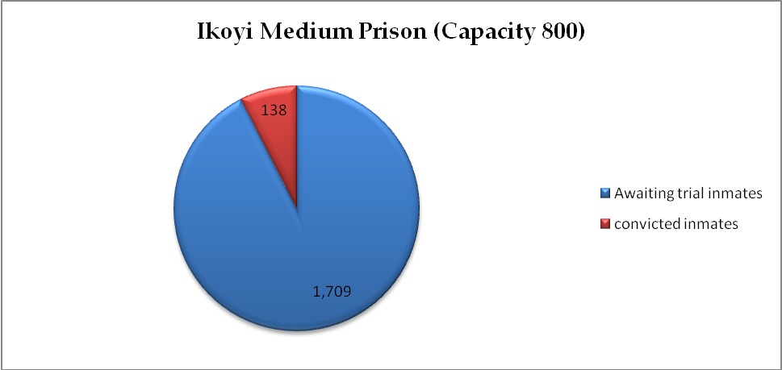

Current inmates = 1,847

1. **Stay of Proceedings & Fast tracking Criminal Trials –**

The administration of justice in Nigeria is notorious for the slow and halting pace at which matters are determined by our court system. It is very common for cases brought to court to span several years before being resolved. Many times the originating parties in a law suit become deceased before judgment is delivered and a pronouncement made as to their claim or interests. Many factors contribute to this characteristic delay of the process of trial justice. Notable amongst them are the technical rules of court which create room for countless interlocutory applications and stay of proceedings’ applications by lawyers. Other issues include lack of diligent prosecution by lawyers, the unavailability of witnesses; overbearing case load on judges as well as the periodic transfer or elevation of judges which usually results in the commencement of trials *de novo*. Common infrastructural challenges, such as power outages militate against the efficient spinning of the wheels of the trial process. All of these factors adversely impact persons under remand detention and occasion huge injustices on them.

Alongside this, trial advocacy tactics also play a major role in trial delays. Applications by parties to stay court proceedings have been identified as a litigant-induced source of delay in criminal trials[16].

Against this background Lagos State legislated a reform of the practice of making interlocutory appeals in Section 273 of the Administration of Criminal Justice Law which provides as follows:

*“****273.*** *Subject to the provision of the Constitution of the Federal Republic of Nigeria, 1999, an application for stay of proceedings in respect of any criminal matter brought before the High Court and Magistrates' Court shall not be entertained until judgment is delivered.”*

**Prescription of Time Limits**

Other measures aimed at expediting criminal trials, introduced in the ACJ Law include the introduction of time limits within which all the relevant steps must be taken from the time of filing of the information up to the date of hearing. Under these time restrictions, once Information is filed, it must be assigned to a judge within 15 days. The court to which the information is assigned is expected within 14 days of assignment to issue hearing notices to witnesses and the defendant. Where the defendant is in custody, then the court shall also issue a reproduction warrant for service on the superintendent of prison. The Chief Registrar of the court is to ensure the prompt service of the notice and information not more than three days from the date they are issued. The intent of these provisions is to fast track criminal trials and prevent needless administrative delays.

Sadly, not much has again changed here.

Findings made from reviewing court records – which reveal filing dates as well as dates on hearing notices - indicate that a sweeping majority of cases filed in both the high courts and magistrates courts are not usually assigned to a judge until well after 15 days from the date of filing. According to 74% of lawyers interviewed, the assignment of a newly filed case to a judge is not likely to take place until well over 30 days from the date of the filing of the information or charge. This view is supported by nearly a total of the sampled prison inmates. Unfortunately, in most instances, the defendant is kept in remand following the refusal of a police bail until whenever a hearing date is scheduled or a bail application can be made before the court. Furthermore many lawyers complain that it is all too common for hearing notices to get lost in the bailiff section of the court or fail to be delivered until after the hearing date scheduled, so lawyers typically take up the responsibility to make regular enquiries about hearing dates from the court staff. The police are often unconcerned as long as the suspect is being remanded.

**The Use of ADR in the Administration of Criminal Justice in Lagos State**

Sections 36(1) and 37 of the Lagos State Magistrate Court Rules, 2009, empower magistrates to refer both civil and criminal cases to forms of Alternative Dispute Resolution for settlement. Where the dispute is of civil nature the consent of both parties is a necessary precondition before a magistrate can refer such a dispute to ADR. However where it is a case involving criminal prosecution, under the applicable rules of court, magistrates may refer only cases involving non-felony offences e.g. minor assault, to State approved channels for ADR. However notwithstanding these provisions ADR remains insufficiently exploited under the administration of both civil and criminal justice in Lagos State. 56% of the magistrates indicate that they are reluctant to apply alternative dispute resolution, even for minor matters of minor assault or debt recovery. According to them both parties must satisfy the court of their joint consent first and also that the means of ADR would guarantee justice in the case. Unfortunately these extra assurances only serve as impediments to the use of a recognized window of dispute resolution which could go a long way in decongesting the cause list of the courts.

1. **Non-custodial Sentencing/Community Service Order:**

Previously in Nigeria, the option of payment of fine in lieu of a term of imprisonment[17] stood as the only alternative forms of non-custodial sentencing recognized and prescribed under applicable laws. This has thus resulted in the over burdening of the prison system over the years.

The ACJ Law has introduced community service as a form of non-custodial sentencing for specific offences and offenders. Under the ACJ Law 2011, courts are now empowered to order persons convicted of minor offences to render prescribed forms of community service or such other forms of community service as may be stipulated at the discretion of the courts as an alternative to imprisonment. Some minor offences over which community service may be imposed as sentence in lieu of imprisonment are environmental offences, petty theft as well as the mis-use or minor destruction of public property amongst other offences. While community service can help reduce over congestion of prisons, it can also help in shielding first time offenders from penitentiary environments where they can mix with more hardened prison populations and getting influenced into a life of deviant behavior. Community Service also serves social objectives as well and helps offenders stay involved in the well-being of the community in which they live.[18]

Under Section 347 (1) of the ACJ Law, magistrates and judges can now impose community service orders to punish people who commit offences punishable with not more than two years imprisonment. Section 347 (3) of the Law on the other hand prescribes certain acts of community service which may be imposed by the courts. The listed acts include environmental sanitation, assisting in the care of children and the elderly in government approved homes, or otherwise any other type of service which the court considers to have a beneficial and salutary effect on the character of the offender. It is also noteworthy that where the terms of an order of community service is breached by an offender, the courts are empowered to proceed to conviction and make a custodial sentence.

Unfortunately however, in spite of the advantages, many Lawyers and even magistrates agree that non-custodial sentences - such as community service and parole – are sparingly used as an alternative to prison. Clearly, there exist, currently, many impediments to the wider use and effective implementation or enforcement of community service orders at the moment in Lagos State.

The reasons for the low use of these instruments are varied: 82% of the magistrates interviewed disclosed many reservations against community sentencing and say that courts presently lack an efficient or adequate system for the enforcement of such orders and most times the offenders abscond without completing the full terms of such orders. These magistrates further stated that although they currently employ community sentence orders for minor offences – such as the theft of mobile phones, (particularly where stolen items have been recovered) or traffic or environmental offences, they are not confident in its effectiveness. They lamented the lack of adequate systems in place for the supervision or enforcement of such sentences, and so most times the sentenced offenders abscond without completing the full terms or time requirements of such orders.[19]

On the other hand, 18% of magistrates reported that due to the challenges of enforcement, they do not apply community service orders at all but prefer the discretion of imposing fines on persons convicted of minor offences or persons constituting first time offenders.

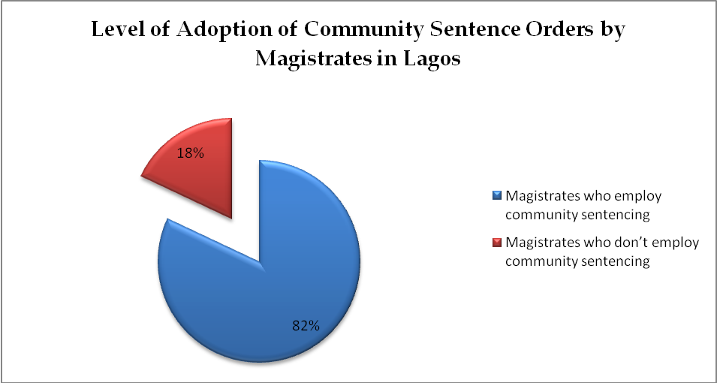

From researchers’ observations the population of prison inmates across many prisons, such as the Federal Prison Badagry, indicate the presence of juveniles and minors being kept in shared detention spaces with adult convicts and hardened criminals. The continued failure of many magistrates to embrace and employ forms of non custodial sentencing such as community sentencing orders could be contributing hugely to rising prison statistics across Lagos State.

*CHALLENGES*

**CHALLENGES FACING THE IMPLEMENTATION OF THE ACJ LAW 2011**

* 1. Most police officers are not familiar with the provisions of the ACJ Law and lack formal training of how to adapt current police procedures to conform with the requirements and standards of the new Law.
  2. The lack of enabling facilities or equipment: there are no facilities provided in police stations to enable the police make video recordings while obtaining statements from suspects.
  3. Conflicting Perceptions of Legality: Some magistrates and police officers express a view of an existing conflict between the provision of the ACJ Law as regards video recordings of confessional statements and the Evidence Act regarding electronic evidence. These conflicting perceptions of the legality of the ACJ Law impede its full implementation. This needs to be addressed.
  4. The absence of pre-designed directions, guides or form templates in the ACJ Law, prescribing the form by which the police or other law enforcement agents should provide information of persons in custody or request extension of remand orders would naturally make it more difficult to secure compliance as law enforcement officials will often cite the lack of available forms as excuses for failing to satisfy statutory requirements. .
  5. Most magistrates are unaware of the creation of the Community Service Unit in the Ministry of Justice in 2012 and of the attachment of two community service officers to each magisterial district in Lagos State.
  6. The community service option as a sentencing alternative to remand and imprisonment suffers from inadequate enforcement as well as the lack of supervisory machinery and personnel.
  7. The police commonly operate under a belief that some of the constitutional safeguards of suspects’ rights are neither practical nor realistic against the reality of crime investigation requirements and risks. It is in the light of this view that they often dismiss such safeguards as being whimsical and adopt their own modus operandi in dealing with the perceived rigours of resolving crime.
  8. Adapting to change is a major challenge among those who should implement the ACJ Law. But the problem goes beyond adaptation to resistance. The principal actors reflect the typical resistance and reservations commonly associated with change. This is evident in the reluctance to accept the changes and new requirements of the law as well as unwillingness to embrace new systems and processes, especially as it involves additional responsibilities for most of the principal actors.

**CHALLENGES FACED BY AJ RESEARCHERS DURING THE STUDY**

1. Some Magistrates we wanted to include in the survey were either on leave or on official assignment and were unavailable to fill the questionnaires administered by the Researchers.
2. Irrespective of prior permissions obtained from the Chief Judge and the Commissioner of Police, Lagos State, some Magistrates and police officers in some commands refused to fill the questionnaires or entertain any form of interview regarding the research.

*CONCLUSION*

**RECOMMENDATIONS**

1. Specific workshops and trainings should be organized for the police, lawyers and the public respectively to make them familiar with the provisions, operations and objectives of the Administration of Criminal Justice Law of Lagos State, 2011 (as amended).
2. Joint stakeholder trainings and workshops on the provisions of the ACJ Law and their reform objectives as well as benefits should be organized and held. Such joint workshops should bring magistrates, lawyers and the police together under one forum so that they can together engage in real experience sharing and analysis, highlight weaknesses in the implementation of reforms and undertake actions to plug identified gaps.
3. Forms or precedents, guides or form templates should be provided to law enforcement operatives to serve as a standard reference but adaptable guide that can be used to make statutory reports under the ACJ Law. Reports such as those required to be made to Magistrates indicating the cases of persons in custody for over durations exceeding the prescribed limits. Or those to justify the making of a remand order. Guidance on how to fill out the various forms should be provided to them.
4. Measures should be reinforced to enhance the degree of professionalism employed by the police in the performance of their functions. This will impact on their attitude and compliance with applicable laws and statutes.
5. Government should fund the provision of infrastructure or equipment that will enable the police make video recording of interrogations or of confessional statements.
6. Effective monitoring mechanisms should be set up and monitoring officers and assessors deployed round magistrate courts from time to time to observe and make reports on the level of compliance by the magistrates with the provisions of the ACJ Law. Such reports should thereafter be submitted to the Chief Judge as well as to the Attorney General and Commissioner of Justice of Lagos State respectively. These reports will form part of the periodic appraisal of the performance of magistrates and will impact on their promotions and transfers thereby serving as a form of incentive to ensure compliance.
7. In a collaboration between the Commissioner of Justice and the Commissioner of Police, a special human rights desk or section should be set up in every police station across the various police commands within Lagos State and lawyers from the State Ministry of Justice should be deployed to monitor the human rights activities of the police as well as receive victims’ complaints through that desk. [20]
8. The Nigerian Bar Association (NBA) in Lagos State should organize and conduct a series of trainings geared towards educating and enlightening its members and lawyers in general, on the various reforms enunciated in the ACJ Law, particularly aspects relating to non-custodial sentencing, plea bargaining, oversight of cases of persons in detention, the safeguards to protect crime suspects from abuse and intimidation, etc etc.

**Organizational Information**

Access to Justice (AJ) is a justice advocacy group that works to facilitate access of marginalized and indigent persons to equal and impartial justice, undertake advocacy to defend values of judicial independence and integrity, defend civil rights and freedoms as well as disseminate legal resources that help achieve these purposes. Access to Justice is registered under the Companies and Allied Matters Act 1990 and has Observer Status with the African Commission on Human and Peoples’ Rights

Since it started operations in 2000, AJ has grown to be one of Nigeria’s leading and well-respected non-profit advocacy groups. AJ is the recipient of the first-ever Nigerian Bar Association **Gani Fawehinmi Award for Human Rights and Social Justice** (2010), the Macarthur Foundation’s **global Award for Effective and Creative Institutions** (2009) and a co-recipient of the 2010 **Legal Award** of *Businessday* Newspaper.

1. For example, a litigation research conducted by Access to Justice in 2011 at the Medium Security Prisons Kirikiri, Lagos found that of 2289 inmates in the prison, 2,165 (i.e. 94.5%) were awaiting trial detainees while only 124 inmates (5.4%) were serving prison sentences.
2. “Role of Police in Lagos criminal justice law reforms”, by Mr. Olasupo Shasore,
3. cap p19, LFN 2004
4. Sections 10 & 11 Criminal Procedure Act, Sections 26, 27 & 41 Criminal Procedure Code
5. Section 16 of the Criminal Procedure Act, cap C41 LFN 2004
6. 54% of the lawyers however indicated that they are unaware of the practice of the police in this regard
7. cap E14 LFN, 2004
8. Section 14 (2) of the EFCC Act
9. Several other cases involving money laundering charges have equally, since the introduction of plea bargain, been resolved through that process by EFCC prosecution in federal high courts across the country.
10. Section 75 of the ACJ Law, 2011
11. Mustapha Mohammed & ors v The State
12. cap C41, LFN 2004
13. Article titled “Magistrates to Check Abuse of Remand Orders” written by Kamarudeen Ogundele and Ofeoluwa Ojo, in *The Nation Newspaper, 15th September, 2011 edition*
14. “Role of Police in Lagos State Criminal Justice Law Reforms” (Ibid)
15. For instance the magistrate court at Ejigbo area of Lagos State
16. An application for stay of proceedings is one where a party in a suit or trial applies to the trial court to stay the hearing of proceedings on the substantive case pending the outcome of an interlocutory appeal before a higher court. Ultimately not only is the substantive trial delayed until the outcome of the appeal but the right of a defendant to fair hearing within reasonable time is adversely affected, not only as to time but as to the strength of evidence. This is because of the potential relocation or death of witnesses. In addition, previous witness evidence becomes lost on the mind of the court. Worse still defendants who are being kept under remand detention suffer prolonged stay in detention under an indefinite stay of proceedings as they await the outcome of an interlocutory appeal.
17. Judicial caning is also applied in Shariah operating jurisdictions
18. The United Nations Office of the High Commissioner of Human Rights, in “Analysis and Commentary” of the Tokyo Rules on non-custodial measures, stated as follows: *“Non custodial measures are of considerable potential value for offenders, as well as for the community, and can be an appropriate sanction for a whole range of offences and many types of offenders, and in particular for those who are not likely to repeat offences, those convicted of minor crimes and those needing medical, psychiatric or social help* ,
19. Two community service officers in the Community Service Unit of the Lagos State Ministry of Justice reveal that they lack mobility and other required facilities to enable them function effectively in the enforcement of community service orders. In view of these challenges they are unable to properly investigate the residential addresses submitted by offenders and their sureties as well as supervise offenders’ compliance with the terms of the issued community service orders at designated work place stations. This often results in sentenced persons sometimes absconding from community service.
20. There are already a few initiatives on the ground like this. Currently, the NHRC with the J4A programme is running a Solicitors legal assistance scheme in designated police stations